**EFFECT OF NMDF ON A RAYLEIGH FADING CHANNEL**

**INTRODUCTION:**

The aim of this project is to use Jake's fading Simulator to generate a Rayleigh fading channel for n samples and to analyze the effect of Normalized Maximum Doppler Frequency on the channel amplitude.

**IMPLEMENTATION:**

1. Jakes' fading simulator (with *M = 8* oscillators or *N = 34*) is used to generate the Rayleigh fading channel. We plot the amplitude of the first 200 channel samples showing the channel amplitude | *h*(*t*) | in dB. We normalize the channel samples such that the average power of each sample is 1.

2. The vehicle is considered to be moving at a constant speed of 60 miles per hour. A user in the vehicle receives wireless signals with carrier frequency 900MHz from a cellular base station. The signal bandwidth is assumed to be 30 KHz. Also we assume that the wireless channel between the user and the base station experiences flat Rayleigh fading. The normalized maximum Doppler frequency in this case will be 0.0027.

3. The above conditions are maintained, and we now simulate a system that has a normalized maximum Doppler frequency of 0.1.

**OBSERVATION:**

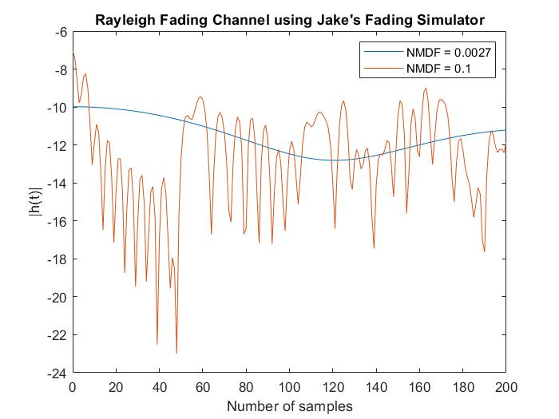

We can see that normalized maximum Doppler frequency will greatly affect the fading channel: the bigger the normalized maximum Doppler frequency, the worse the fading channel; the smaller the normalized maximum Doppler frequency,

the flatter the fading channel. We can also see that once the normalized maximum Doppler frequency is decided, the fading channel is decided; No other information is needed.